NOTICE OF 30-DAY COMMENT PERIOD ON THE 2025 ACTION PLAN
AND
NOTICE TO THE PUBLIC OF REQUEST FOR RELEASE OF FUNDS

City of Texarkana, Arkansas Texarkana Gazette

TO: ALL INTERESTED AGENCIES GROUPS AND PERSONS:

Thirty days after this publication (on or about June 30, 2025) the City of Texarkana, Arkansas, USA intends to request the Department of Housing and Urban Development (HUD) to release Federal funds in the amount of $300,959.00 under Title I of the Housing and Community Development Act of 1974 (P.L. 93-383) for:

Community Development Block Grant
Project No. B-25-MC-05-007

2025 Action Plan Projects
Project Name | Funding
Public Facilities | $113,289
Housing (Minor Repairs) | $ 55,000
Clearing & Housing Demolition | $ 50,000
Public Service | $ 25,000
Grant Administration | $ 57,670

All interested agencies, groups and persons, disagreeing with the projects included in the 2025 Action Plan are invited to submit written comments for consideration by the City to the address as set forth above. Such written comments must be received at the address specified within thirty (30) days after this publication (June 27, 2025). All such comments so received will be considered and the City will not request the release of funds or take administrative action on the project prior to the date specified in the preceding sentence.
.
The 2025 Action Plan and Five Year Consolidated Plan for the proposed project have been made by the City of Texarkana, Arkansas, which documents the projects, and more fully sets forth reasons why such activities are proposed. The Action Plan is on file in the Public Works office, City Hall lower level, 216 Walnut Street, and is available for public examination and copying upon request between the hours of 8:00 A.M. and 4:30 P.M., Monday through Friday.

Public Comments on Action Plan
All interested agencies, groups and persons, disagreeing with this decision are invited to submit written comments for consideration by the city to the address as set forth above. Such written comments must be received at the address specified within thirty (30) days after this publication (June 27, 2025). All such comments so received will be considered and the City will not request the release of funds or take administrative action on the project prior to the date specified in the preceding sentence.

Release of Funds
The City of Texarkana, Arkansas will undertake the activities described below with Community Development Block Grant funds under Title I from its fiscal 2025 program under grant numbered B-25-MC-05-007 from the Housing and Community Development Act of 1974. The City of Texarkana, Arkansas is certifying to HUD that Tyler Richards, in his official capacity as City Manager, consents to accept the jurisdiction of the Federal courts if an action is brought to enforce responsibilities in relation to environmental reviews, decision-making and action; and that these responsibilities have been satisfied. The legal effect of the certification is that upon its approval, the City of Texarkana, Arkansas may use the Block Grant funds and it will have satisfied its responsibilities under the National Environmental Policy Act of 1969, HUD will accept an objection to its approval only on one of more of the bases and the procedure described in 24 CFR Part 58.75. Objections are to be addressed to HUD, Little Rock Office – Region VI, TCBY Tower – Suite 900, 425 West Capitol Avenue, Little Rock, AR 72201-3488.

Objections to the release of funds on bases other than those stated above will not be considered, by HUD. No objections received later than thirty (30) working days after HUD will consider publication (June 30, 2025).

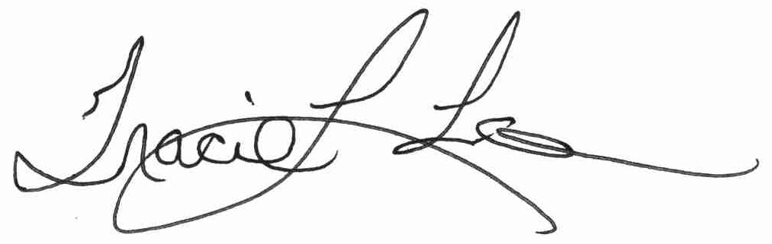
Tracie Lee
Interim Public Works Director
P.O. Box 2711
Texarkana, AR 75504-2711

